Case Study on Mental Health of Technical worker on the year 2014

**Author - Mukesh Sundar P**

**Introduction:**

In an era marked by rapid technological advancements and evolving work environments, it is imperative to explore and understand the intersection of mental health and the tech industry. This healthcare analytics report delves into critical insights extracted from a comprehensive survey conducted in 2014 within the tech sector. By harnessing the capabilities of Power BI, we aim to shed light on various aspects of mental health, gender diversity, workplace dynamics, and the impact of these factors within the technology workforce.

**Background:**

The tech industry has long been associated with innovation, dynamism, and progress. However, it is not immune to the challenges posed by mental health issues. The report focuses on analysing data collected from individuals working in the tech sector during the year 2014. This dataset provides a valuable opportunity to gain insights into the mental health landscape within the industry.

**Data Source:** https://data.world/datasets/health

**Data Cleaning Steps:** Using python I have cleaned the data by removing null values and replacing some important missing and wrong data with ‘Unknown’ or with average of that specific column.

**Data Transformation:** I transformed the cleaned data using Power Query Editor in Power BI.

**Data Visualization:** I did the whole dashboard in Power BI.

**The Dashboard:**

**Page: 1**

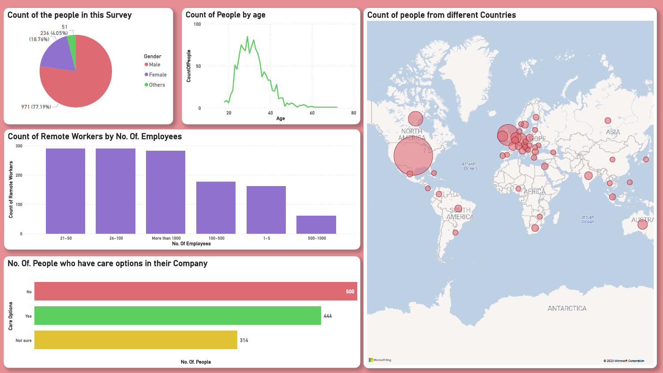

**Page: 2**

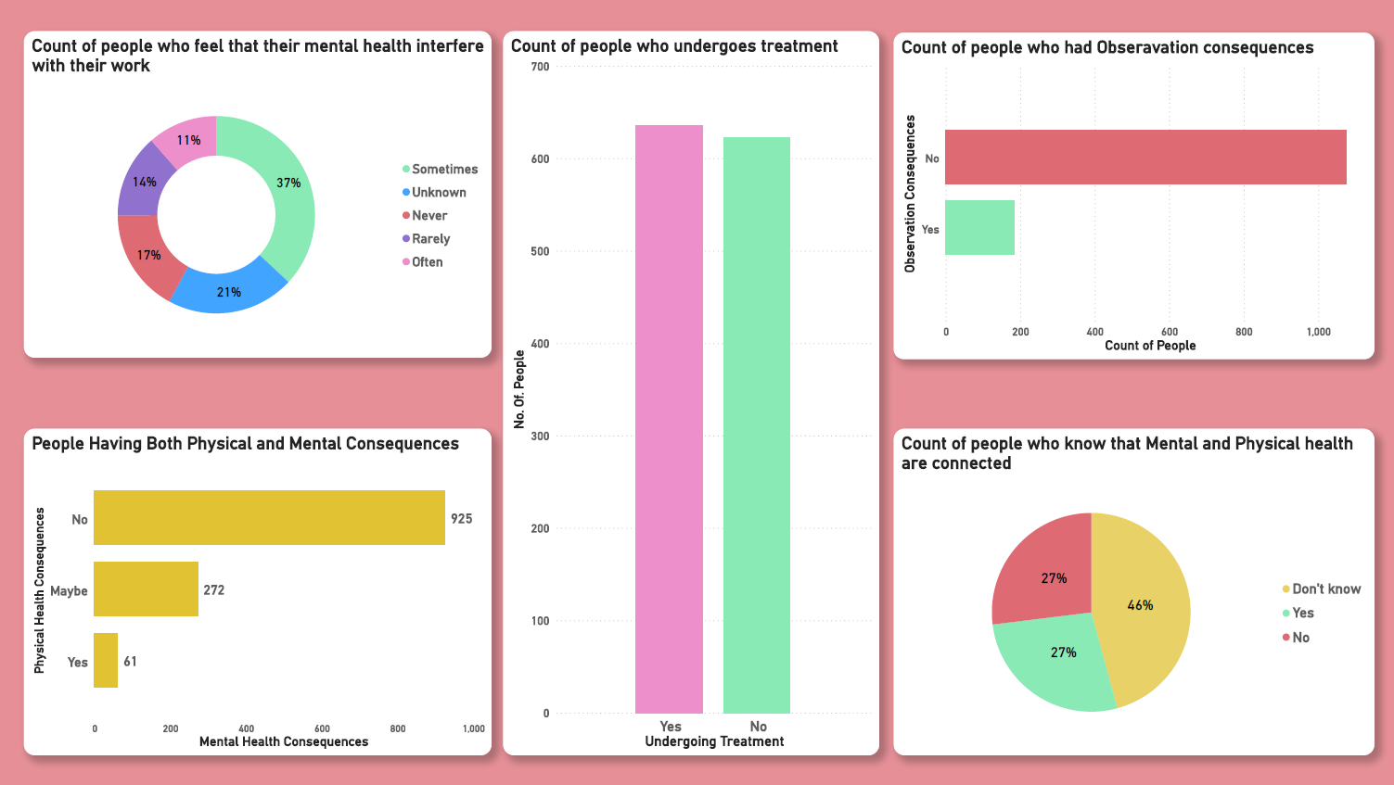

**Age Distribution**

**Description:** Visual representation of the age distribution of respondents in the tech industry.

**Visualization Type:** Bar Chart

**Explanation:** This bar chart illustrates the distribution of age groups among survey respondents. It provides insights into the age demographics of individuals in the tech sector.

**Gender Distribution**

**Description:** Visual representation of the gender distribution among survey respondents.

**Visualization Type:** Pie Chart

**Explanation:** This pie chart displays the distribution of genders among survey participants, highlighting the gender diversity within the tech industry.

**Country Distribution**

**Description:** Geographic representation of survey respondents by country.

**Visualization Type:** Map

**Explanation:** This map visualization showcases the geographic distribution of survey respondents by country. It provides an overview of the global reach of the survey.

**Mental Health Consequences**

**Description:** Relationship between mental and physical health consequences.

**Visualization Type:** Stacked Bar Chart

**Explanation:** This stacked bar chart demonstrates the relationship between mental and physical health consequences as reported by survey respondents. It helps identify patterns and correlations.

**Treatment Status**

**Description:** Proportion of respondents receiving mental health treatment.

**Visualization Type:** Pie Chart

**Explanation:** This pie chart indicates the proportion of survey participants who reported receiving mental health treatment. It sheds light on the prevalence of treatment-seeking behaviour.

**Work Interference**

**Description:** Impact of mental health issues on work.

**Visualization Type:** Bar Chart

**Explanation:** This bar chart illustrates how mental health issues interfere with work. It provides insights into the challenges individuals face in the workplace due to mental health.

**Remote Work and Company Size**

**Description:** Relationship between remote work and company size.

**Visualization Type:** Clustered Bar Chart

**Explanation:** This clustered bar chart explores the relationship between remote work arrangements and company size. It helps identify trends in remote work adoption.

**Benefits and Care Options**

**Description:** Availability of mental health benefits and care options.

**Visualization Type:** Stacked Bar Chart

**Explanation:** This stacked bar chart visualizes the availability of mental health benefits and care options within the tech industry. It assesses the level of support provided by employers.

**Mental vs. Physical Health**

**Description:** Comparison of attitudes toward mental and physical health in the workplace.

**Visualization** **Type:** Pie Chart

**Explanation:** This pie chart compares attitudes toward mental and physical health in the workplace, highlighting the importance placed on each.

**Observation Consequences**

**Description:** Proportion of respondents reporting consequences due to observing mental health issues.

**Visualization Type:** Bar Chart

**Explanation:** This bar chart displays the proportion of respondents who reported experiencing consequences in the workplace due to observing mental health issues in their colleagues.

**Insights:**

The Power BI dashboard on mental health in the tech industry presents a comprehensive view of the workforce's well-being in 2014. Across various dimensions, we observe a workforce diverse in age and gender, yet facing shared challenges. Notable findings include:

**Age Diversity:** The tech industry welcomes professionals across different age groups, emphasizing the importance of tailored mental health support programs.

**Gender Equity:** Gender diversity is evident, highlighting the need for inclusive policies and mental health initiatives that cater to all genders.

**Mental Health Impact:** Workplace stress has tangible consequences, with many respondents reporting mental and physical health challenges due to work-related stress.

**Treatment Gap:** While employees acknowledge the importance of mental health, a significant proportion do not seek treatment, pointing to potential barriers or stigma.

**Work Interference:** Work interference due to mental health issues is a shared concern, calling for a workplace environment that accommodates employees' mental well-being.

**Benefits and Care:** Varied availability of mental health benefits underscores the need for organizations to enhance support structures.

**Attitudes towards Health:** Respondents place significance on both mental and physical health, advocating for a holistic approach to employee well-being.

**Observation Consequences:** Observing mental health issues in colleagues can lead to workplace repercussions, emphasizing the importance of fostering a supportive and understanding work culture.

This dashboard provides actionable insights, highlighting the imperative for organizations to prioritize mental health, reduce stigma, and create environments where employees can thrive both personally and professionally.

**Conclusion:**

In conclusion, our healthcare analytics project utilizing Power BI offers a valuable glimpse into the mental health landscape within the tech industry. The analysis underscores the significance of mental health as an integral component of a thriving and diverse workforce.

By embracing the insights presented in this report and implementing the recommended strategies, organizations can pave the way for a workplace culture that prioritizes mental health, fosters inclusivity, and ultimately propels the tech industry towards a brighter and more compassionate future.